The Evolution of Cryptography:
An Overview of Classical Ciphers and Their Legacy

Christopher Gonzalez, Joseph Ipanaque, Isaia Jimenez, Daniel Minton

Professor Jennifier Holst

CSCI 401

19 May 2025

Individual Member Project Report
Christopher Gonzalez:
For this project, it was my responsibility to research and implement the two classic ciphers of my choice in C++, which were the Caesar Cipher and the Columnar Transposition Cipher. The reason I chose the Caesar Cipher was because it is often viewed as the starting point of modern-day cryptography. While later research would reveal this to be not entirely accurate, it's a well-known and easy-to-understand cipher that many people can recognize. On the other hand, I picked the Columnar Transposition Cipher specifically because it is lesser known by the average person and presented a challenge I was satisfied with. I am not claiming to be an expert in C++ by any means, but I wanted to push myself and create something I could be proud of, especially given this project is the final requirement standing between me and my bachelor’s degree after four years of work at John Jay College.
In fact, it was I who proposed the idea of building a secure communication system at the beginning of the semester. The inspiration came from one of my favorite classes in the Computer Science & Information Security program: Cryptography and Cryptanalysis (CSCI 360), which I took in the Spring 2023 semester. While the course leaned more toward the mathematical side of cryptography, I remember working on a project where we had to write programs to decrypt four different ciphertexts we covered in class. Of the four, three of those ciphers were Caesar, Affine, and Vigenère, which are also some of the ciphers in our secure communication system. My first attempt at a Caesar Cipher back then was very basic, so I made a point to improve on the Caesar cipher for this project.
In addition to implementing the two ciphers, I also took on the role of adding a ninth option in which the program chooses a cipher at random and a tenth option to end the session, along with integrating all the other six ciphers done by my team members into the final C++ program and standardizing their structure. Looking back, I feel genuinely accomplished of what I contributed and what our team accomplished together.

Joseph Ipanaque:
For our capstone project, my responsibility was to research and implement two modern ciphers: ROT13 and XOR. These ciphers, while not considered secure by today’s standards, were selected to represent the digital shift in cryptography and highlight how foundational logic operations continue to influence computing today.
I chose ROT13 because of its simplicity and relevance as a modern adaptation of the Caesar cipher. It shifts each letter by 13 positions in the alphabet, making it self-reversible—applying the cipher twice returns the original message. ROT13 is still used in online forums and software to obscure sensitive or spoiler content. My C++ implementation supports both encryption and decryption with minimal user input, reinforcing the concept that even simple ciphers can serve practical purposes in the digital space.
The XOR cipher, while similarly simple, provided more flexibility and introduced low-level operations into the project. I implemented a version that accepts both a message and a key from the user, applying a bitwise XOR operation to encrypt and decrypt simultaneously. XOR encryption, though basic in its standalone form, is foundational in many real-world cryptographic systems, including stream ciphers, RAID data recovery, and checksums. To demonstrate this functionality, my implementation outputs both the encrypted and decrypted results so users can see the reversible nature of the cipher in real-time.
In addition to coding these two ciphers, I contributed to internal testing of the entire program, ensuring input validation, consistency across cipher options, and functional integration into the overall menu system. I also helped draft content for our presentation poster’s modern encryption section, highlighting ROT13 and XOR’s roles in contemporary applications.
Through this project, I deepened my understanding of how classical and modern cryptography intersect, and how even simple algorithms can have impactful use cases. It was rewarding to contribute to our group’s vision of showcasing cryptographic evolution through hands-on coding and historical analysis.

Isaia Jimenez:
For our capstone project, I was responsible for researching and implementing two classical ciphers: the Atbash cipher and the Affine cipher. These encryption methods are some of the building blocks in the history of cryptography and helped us show how secret communication has evolved — from flipping letters to crunching numbers.
I chose the Atbash cipher because of its simplicity. It’s one of the earliest known substitution ciphers, used by Hebrew scholars around 500 BCE, and works by reversing the alphabet so that each letter maps to its opposite (A ↔ Z, B ↔ Y, etc.). It’s a great way to show the concept of security through obscurity without needing to dive deep into complex math. It’s straightforward, easy to explain, and something almost anyone can understand or even do by hand. I implemented Atbash in our C++ program using ASCII manipulation, supporting both uppercase and lowercase characters. On the poster, I highlighted its historical use and how, while it’s not secure today, it paved the way for more advanced techniques.
Then I decided to take things up a notch with the Affine cipher. This one brought math into the mix, using a formula:
C = (aP + b) mod m
where a and b are keys, P is the letter’s position, and m is the size of the alphabet. It was a fun challenge to build this out in C++, especially creating the modular inverse function for decryption. I made sure the code validated inputs and handled all the edge cases. What I really liked about Affine is that it shows how math starts to shape stronger cryptography, making it much harder to crack than simple substitutions like Atbash or Caesar. It was rewarding to implement and even more fun to demonstrate.
Overall, this project let me dive into the history of encryption and bring those ideas to life through code. I got to teach others how these ciphers work and see firsthand how classical techniques still shape how we protect data today.

Daniel Minton:
For this project, it was my responsibility to research and implement two ciphers of my choice in C++, and I chose to explore the Rail Fence Cipher and the Vigenère Cipher. What drew me to these two ciphers were their relatively straightforward, although certainly complex, implementations. Another draw to these were their lesser known natures compared to the famous founding ciphers within cryptography like the Caesar cipher, and modern ciphers which utilize incredibly complex algorithms like AES and RSA.
A fundamental characteristic of both ciphers is their utilization of a key: Rail Fence requires an integer to determine the number of rows to utilize, and Vigenère requires a string that acts as a keyword. For Rail Fence, encryption is performed by receiving the desired amount of rails and writing the plaintext characters diagonally downward until the bottom rail is hit, upon which the writing is continued diagonally upward. The ciphertext is formed by concatenating the characters from row one, then row two, and so on. The cipher can be programmed to ignore spaces or to incorporate them into the ciphertext. Largely up to the programmer’s discretion, I chose to accept spaces as valid characters so as to retain them once the text is decrypted. For Vigenère, encryption is performed by receiving a keyword which is repeated to match the length of the plaintext. In other words, every letter of plaintext is appropriately matched with a letter of the keyword. Using a matrix known as a Vigenère table consisting of alphabets written out, each one shifted one position to the left of the previous, determining the ciphertext is done letter by letter following a “coordinate” system of (x,y) -> (plaintext character, keyword character). The accepted plaintext characters available for encryption is up to the programmer’s discretion, and for simplicity I chose to only allow for letters to be encrypted while preserving spaces, numbers, and punctuation.

Project Debrief
In the beginning of this project, the first challenge was determining which ciphers to implement using C++. Prior communication established that the program would feature a menu allowing users to encrypt or decrypt messages using any of eight cipher options. Additionally, a ninth option would enable the program to randomly select a cipher, while a tenth option would end the session. With a team of four members, the workload was divided by assigning each member for two ciphers. The goal in selecting these ciphers was to illustrate the evolution of cryptography and its applications throughout human history. Ultimately, the ciphers selected were Caesar, Columnar Transposition, XOR, ROT13, Atbash, Affine, Vigenère, and Rail Fence.
The next challenge was determining the order of the selected ciphers. This proved to be a minor issue, as some ciphers are inherently more complex than others. To display the chronological progression of cryptography, we decided to arrange the ciphers in historical order. This required research into the origins and/or historical use of each cipher should the origins be unclear. After thorough investigation, we established the following sequence: Atbash, Caesar, Rail Fence, Columnar Transposition, Vigenère, Affine, ROT13, and XOR.
From a technical standpoint, the most significant challenge was implementing the selected ciphers in C++. Most (if not all) of these ciphers predate modern computing, which meant a deep understanding of their characteristics and mathematical principles was necessary. Once this was done, translating these methods into C++ required a significant amount of planning and execution. Fortunately, there was an abundance of online resources and documentation which aided in this process. For example, given that all the ciphers rely on alphabetic characters, we used ASCII values for letter shifting in ciphers like Atbash and Caesar. This was achieved by adjusting the ASCII value based on the cipher key and using modular arithmetic to ensure the program stays within the alphabet.
Working on this project provided us with valuable insights into the field of cryptography, both historical and modern. One of the most surprising discoveries came when we were arranging the ciphers we selected in chronological order. Contrary to popular belief, the Caesar cipher was not the earliest cipher ever created. Through our research, we found that the first known substitution cipher was actually the Atbash cipher. This cipher was developed by the ancient Hebrews around 500 BCE, predating the Caesar cipher by approximately 400 years. Interestingly, both ciphers work using the principle of letter shifting. While the Atbash cipher reverses the entire Hebrew alphabet, the Caesar cipher shifted each letter of the Roman alphabet by three positions.
Due to the simplicity of the Caesar cipher, one might assume its relevance and usage in modern cryptography would be minimal. However, the research phase of our project revealed that the ROT13 cipher (which is closely based on Caesar's method) had some applications in modern computing. Although not used for secure encryption, ROT13 was employed for basic text obfuscation. A notable example is in Microsoft Windows XP, where ROT13 was used to obscure certain registry keys, particularly:
HKEY_CURRENT_USER\Software\Microsoft\Windows\CurrentVersion\Explorer\UserAssist
For context, this registry key logs information about recently accessed programs and usage patterns of the user. The use of ROT13, which shifts each letter by 13 positions in the alphabet, made the stored information less visible to casual users or search tools. While not secure by cryptographic standards, ROT13 helped obscure data from unintended discovery.

Final Work
The primary technology we investigated was the C++ programming language. C++ is one of many languages in the computing landscape, alongside others such as Python, Java, and SQL. While C++ may not enjoy the same popularity as some of these counterparts, it remains a foundational language that is widely utilized for systems-level software, high-performance applications, and game engine development. Although our program does not necessarily fall within the category of high-performance applications, we chose to implement our project in C++ as a tribute to the programming courses we completed at John Jay College, particularly Cryptography and Cryptanalysis.
Developing the program in C++ proved more challenging than it would have been in another language, such as Python. This is largely due to Python’s cryptography library, which offers a variety of cryptographic algorithms and tools. Although this library may be unnecessary for simple ciphers like Caesar, it is a valuable resource for handling more advanced encryption techniques. Despite this fact, it is not the main goal of our project. As previously noted, the objective was to illustrate the evolution of cryptography and its practical applications. It is also worth mentioning that Python has the caesarcipher package on the Python Package Index (PyPI), which could facilitate Caesar cipher implementation.
The success of our project relied on proficiency in C++ for cryptographic applications. Throughout the development process, it became clear that several of the ciphers required specific functions and libraries to operate effectively. During our studies at John Jay College, we became familiar with essential C++ libraries such as #include <iostream> and #include <string>. These libraries were integral to enabling user interaction with the program, allowing users to input messages for encryption and decryption. Given the interactive nature of the program, we had to account for unexpected or invalid user input, which posed a risk of program failure. To address this, we implemented exception handling using the #include <limits> library. This allowed the program to handle improper input without crashing.
Additionally, implementing more complex ciphers, such as the Columnar Transposition Cipher, required advanced functionality. The cipher operates by writing a message in rows and then reading the transformed text in columnar order based on the alphabetical sequence of a keyword. To accomplish this in C++, we constructed a matrix to store the input message and applied transformations to generate the output. For this purpose, we utilized the #include <bits/stdc++.h> library, which provides access to functions such as transform and memset. The transform function applies a specified operation to each element in a range and stores the result in another range, while memset is used to initialize blocks of memory with a specified value. These functions were crucial for the efficient implementation of the Columnar Transposition Cipher.
To run our program, users must have access to a C++ compiler, which is a software that can be installed on their local device. One popular C++ development environment for all devices is Visual Studio, developed by Microsoft in 1997. Another popular option, that is exclusive to macOS users, is Xcode, which was introduced in 2003. Both platforms have undergone numerous updates to support a wide range of modern libraries and community-developed features, although they do require a significant amount of disk space. For users unable to install a local compiler, free online alternatives are available. During the development of this project, we used OnlineGDB, a web-based C++ compiler, which is demonstrated below:
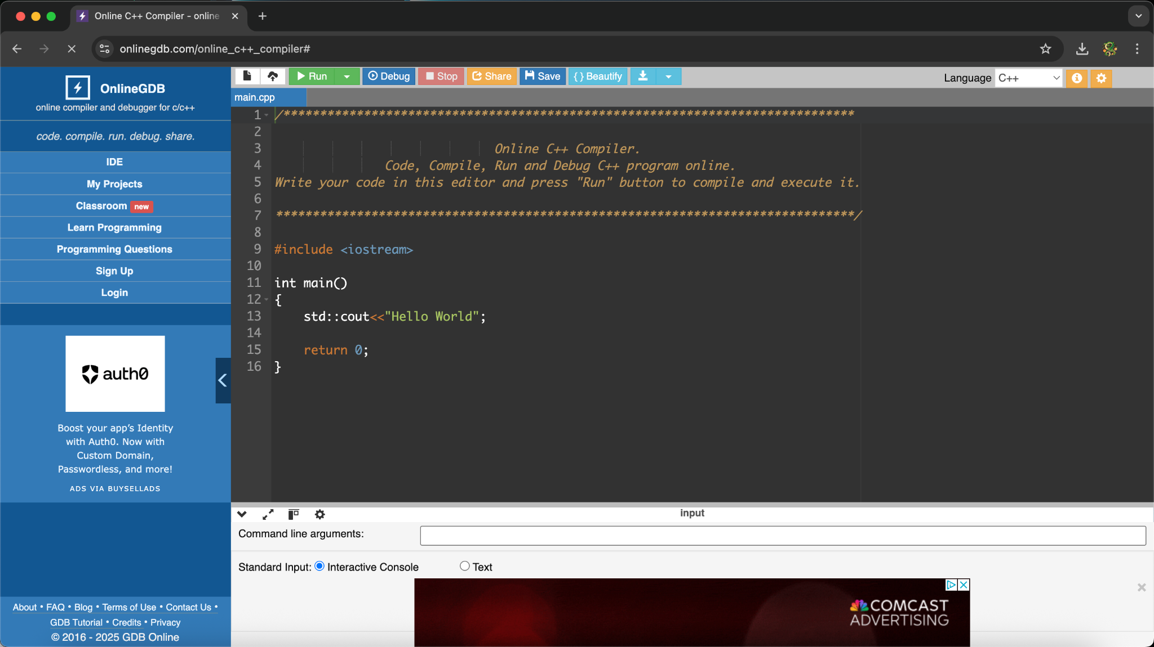
Once a reliable compiler is prepared, users should download the program file to their device and load them into the compiler environment. Running the program initiates a welcome screen followed by a main menu that displays the available cipher options:
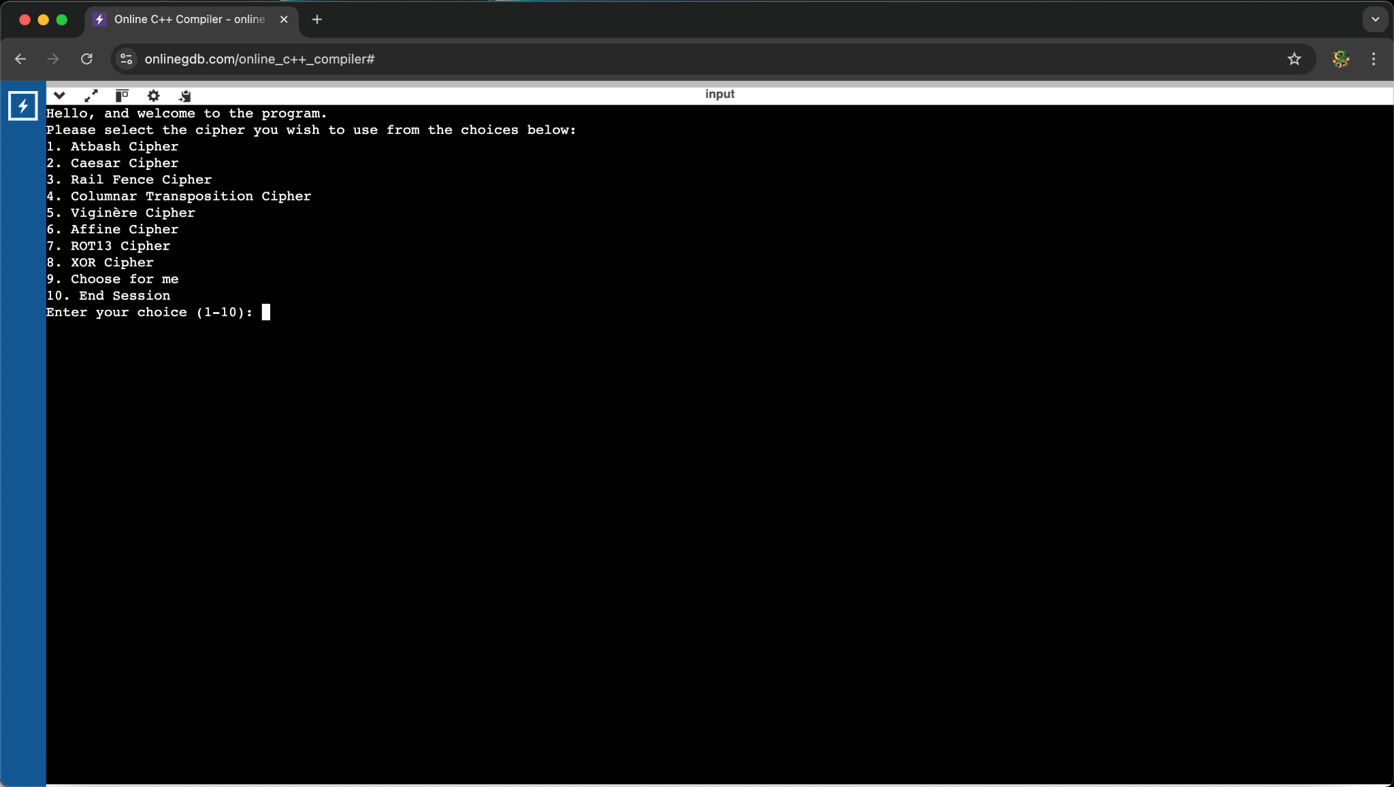
The menu requires users to input their selection as a number. For example, to use the Atbash Cipher, users must enter 1. If a user enters non-numeric text, an error message will appear, prompting them to try again.
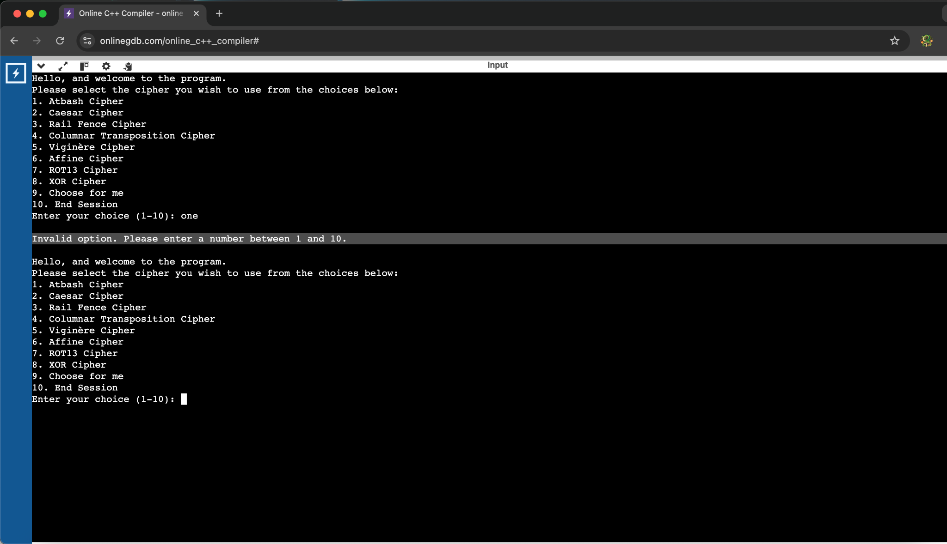
On a similar note, entering a number outside the valid range (1–10) will result in the same error message and procedure.
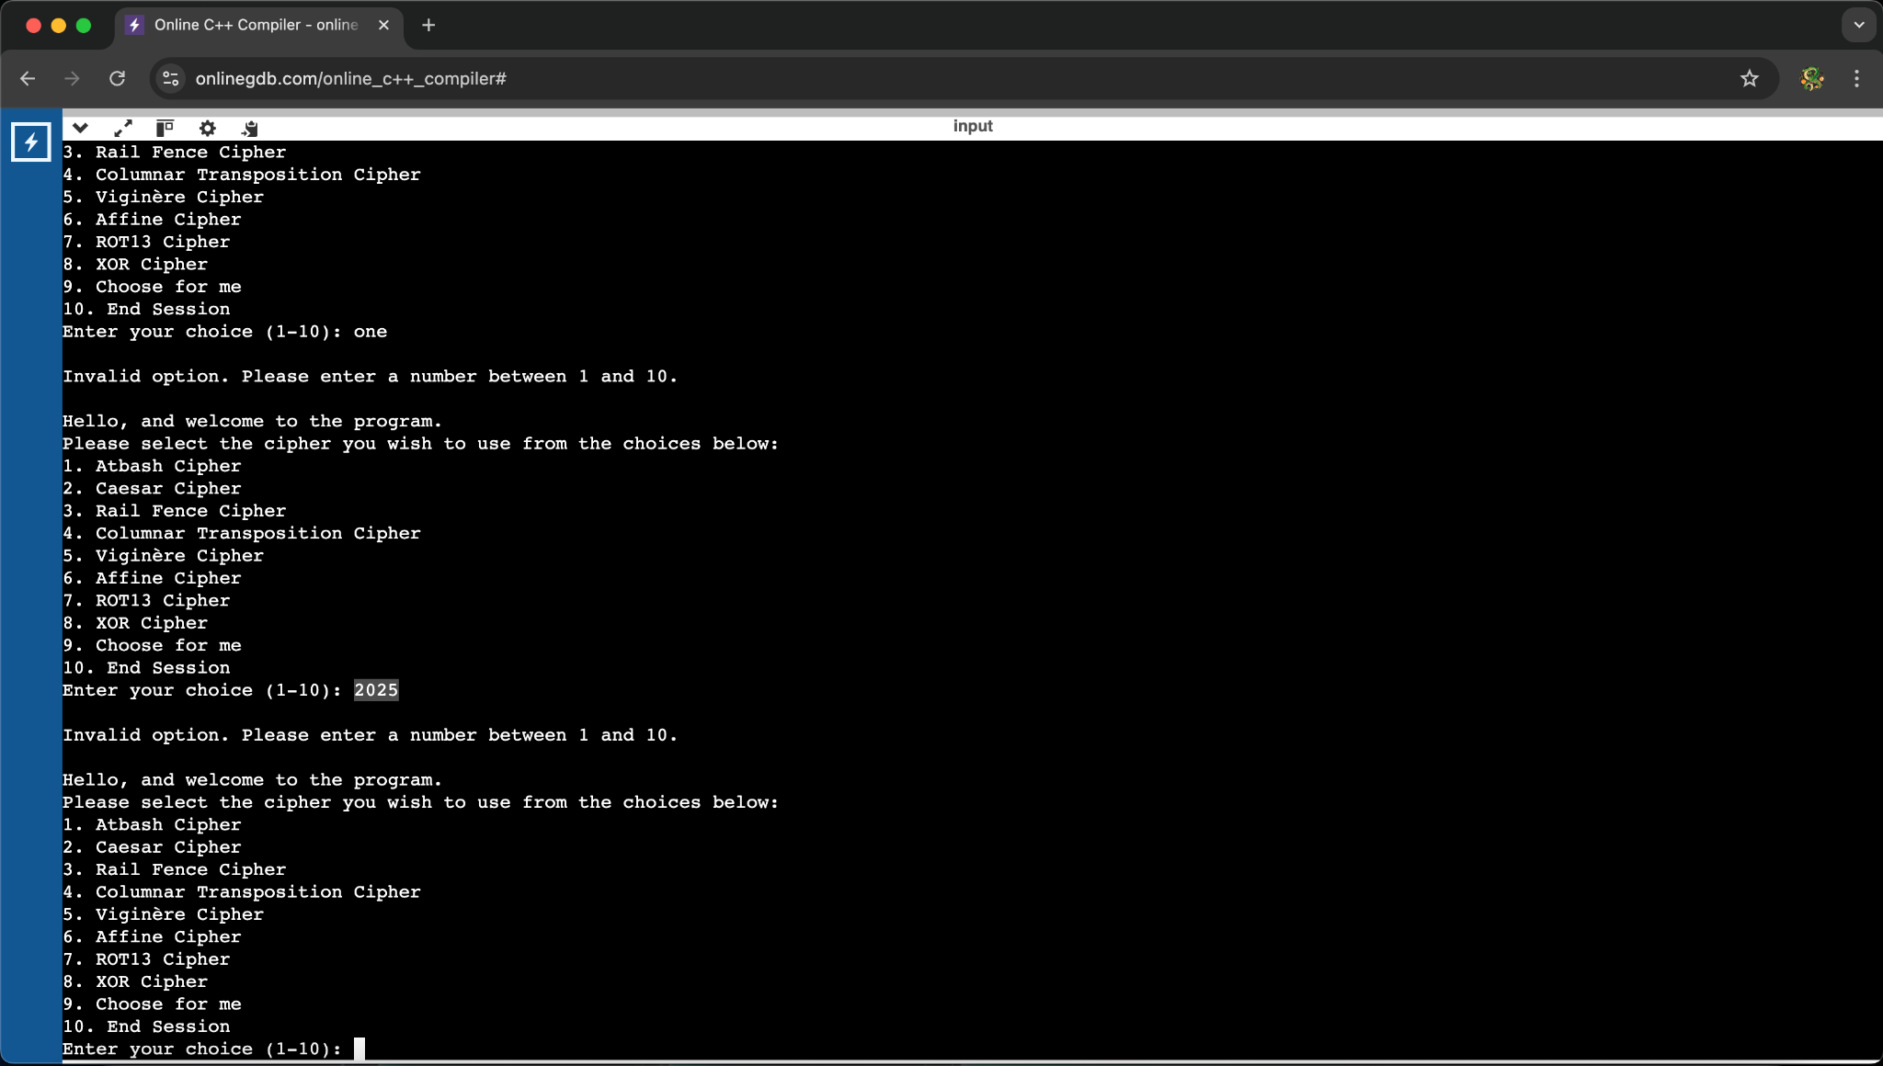
After selecting a cipher, users are then prompted to choose between encryption and decryption by entering 1 or 2, respectively. Input validation is also enforced at this step to ensure correct operation throughout the session.
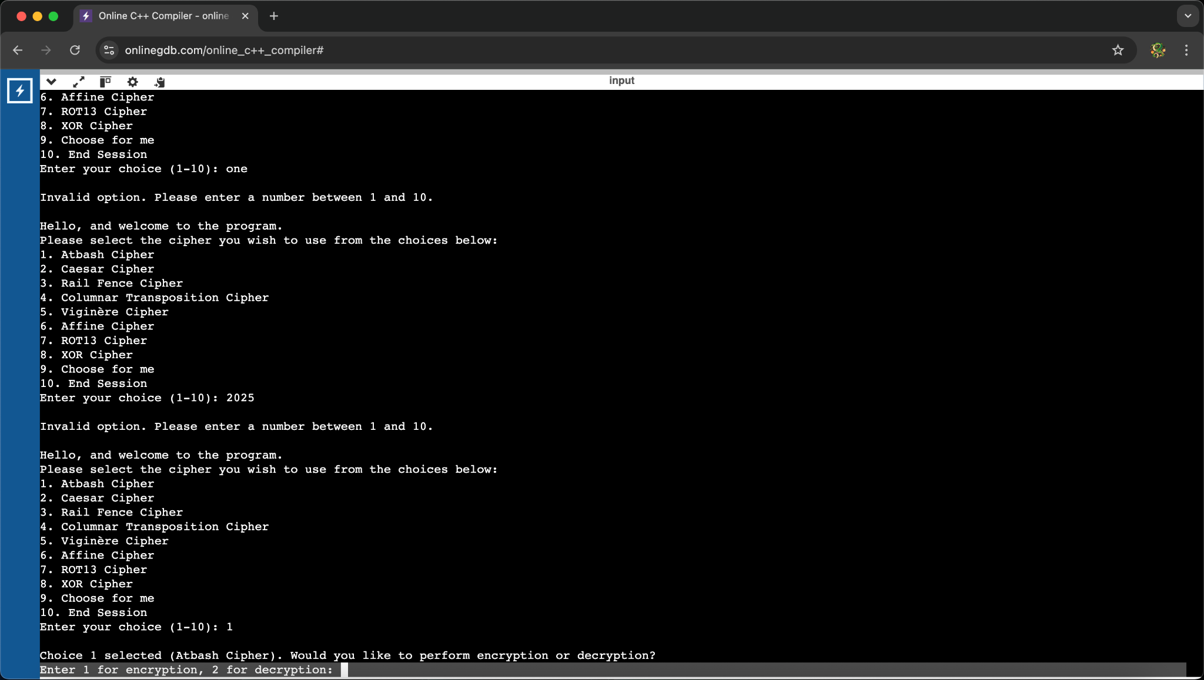
If encryption is selected, users are prompted to enter the plaintext message:
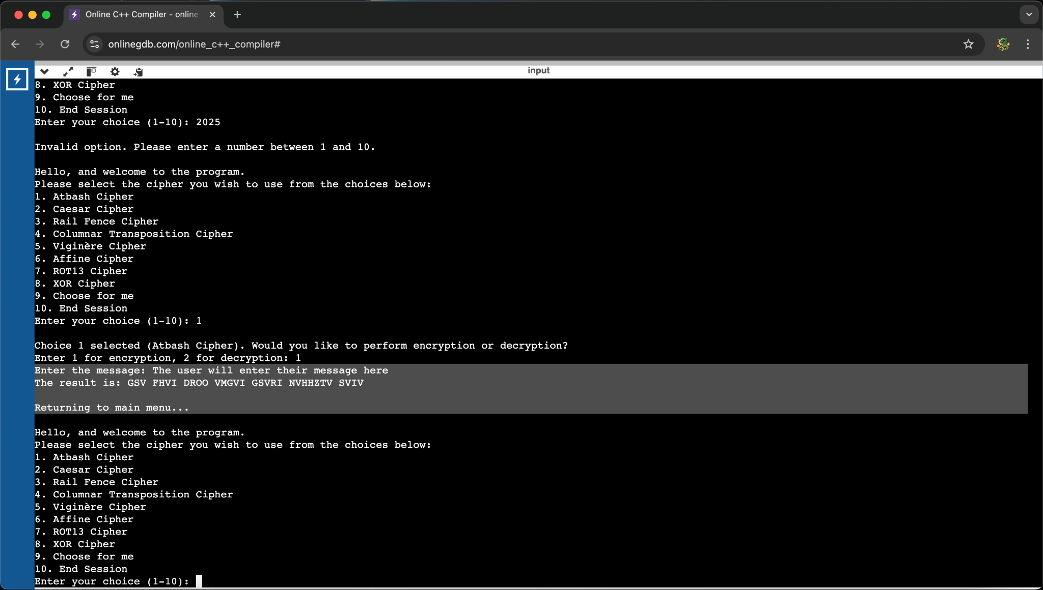
The program then displays the resulting ciphertext for reference. After completion, the program returns to the main menu, allowing users to decrypt their message or choose another cipher. To decrypt a previously encrypted message, users follow a similar process, but select the decryption option instead.
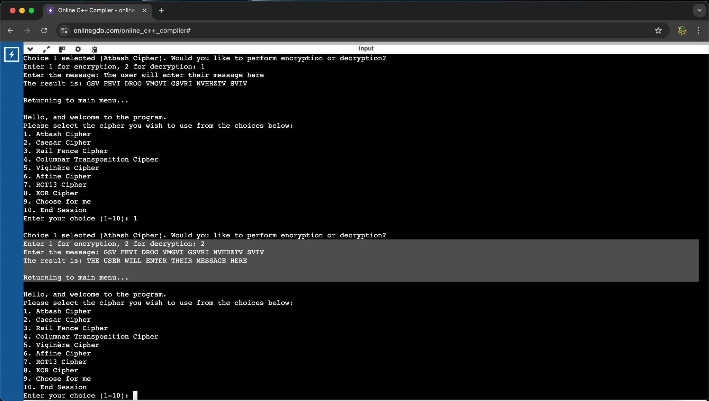
All ciphers in the program follow this standard flow, with the exception of the XOR cipher. Unlike the other ciphers, XOR operates on both printable and non-printable ASCII characters. When using this cipher, users must input both the message and key. The program then displays the encrypted and decrypted output simultaneously. Finally, to exit the program, users must enter 10 at the main menu.
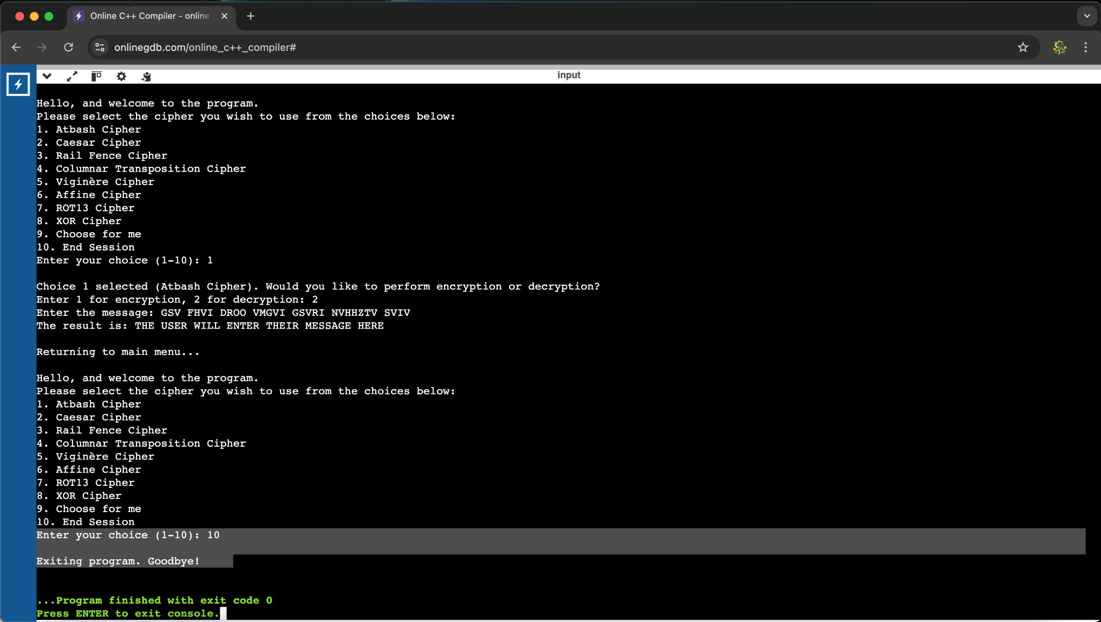
For our project, the only technical resources referenced were online articles and related to the ciphers we implemented. As previously noted, most of these encryption methods originate from eras preceding modern computing, which required research into their principles and effective strategies for translating them into computer code. We utilized platforms such as GeeksforGeeks, TutorialsPoint, and Crypto Corner to gain a comprehensive understanding of some practical implementation techniques. These sources offered valuable guidance on the ciphers, as well as insights into effective programming approaches for our purposes. Each cipher posed distinct challenges in terms of logic and structure, requiring careful analysis and thoughtful adaptation to ensure success.

